Advent Mission 2023
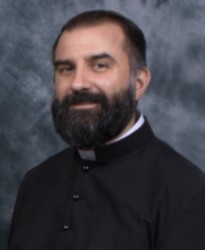

Date: December 4-6, 2023
Time: 6:00 – 7:00 p.m.
Place: St. Elizabeth Seton Catholic Church
Speaker: Dcn. Adam Conque

TITLE: God is With Us: A Eucharistic Revival in Faith,
Hope, and Charity
-The Amazing Biblical Roots of the Eucharist in the Old Testament
-The Faith of the Church in the Eucharist in the New Testament
-The Church's Faith in the Eucharist is Biblical Faith

NIGHT 2: O Marvelous Thing!: Enkindling Hope Through
Eucharistic Miracles
-What is a Eucharistic Miracle?
-The Stories of the Most Amazing and Most Recent Eucharistic
Miracles
-Our Lord Desire Us to Place All Our Hope and Trust in Him,
Present in the Eucharist

NIGHT 3: Heart to Heart: Our Hearts Burn with Charity in His
Eucharistic Presence
-The Inexhaustible Treasure of God's Love for Us Present in Every
Mass
-How do we return God's love for us through the Eucharistic
Sacrifice?
-Adoration of the Blessed Sacrament, the School of Charity with
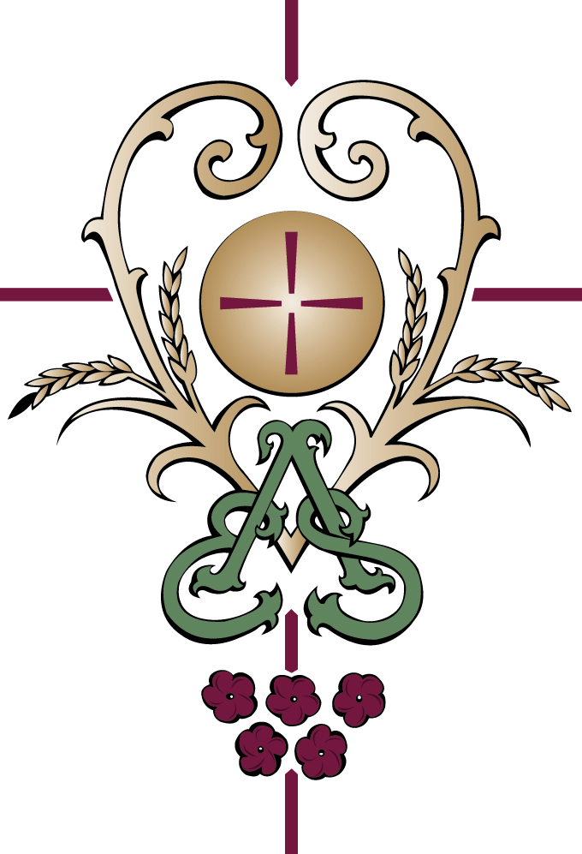
Our Lord
